1. Created 10 tables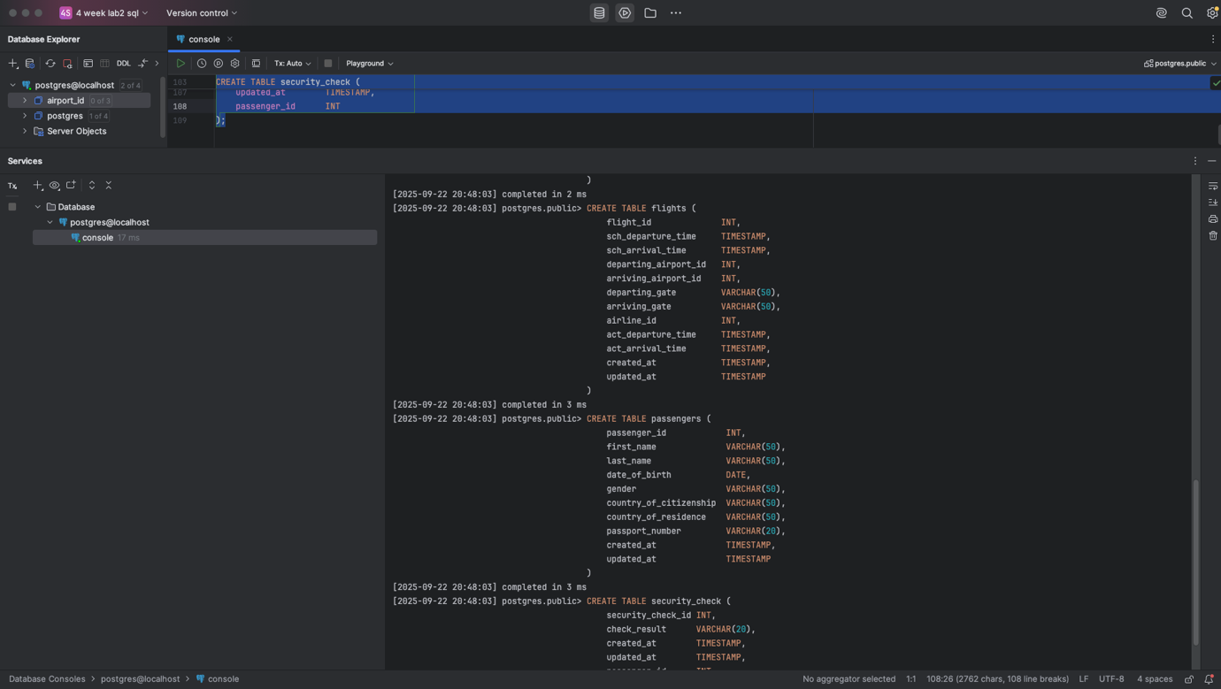

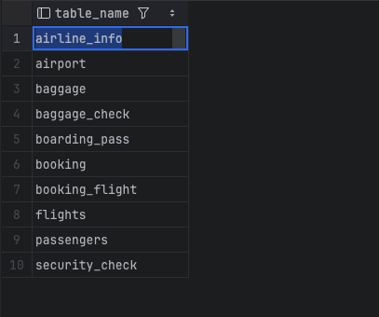

1. Made primary keys for tables 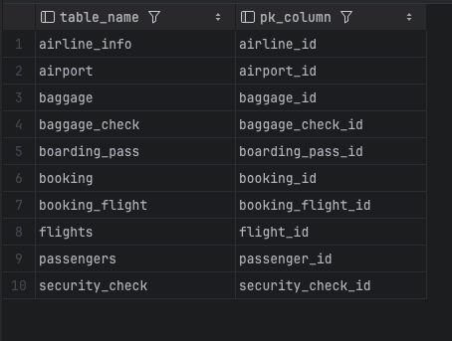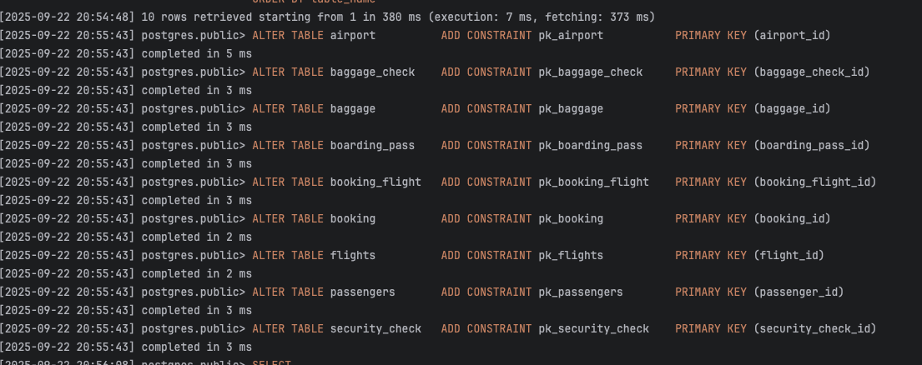
2. Alter columns for tables and setted this columns as not null

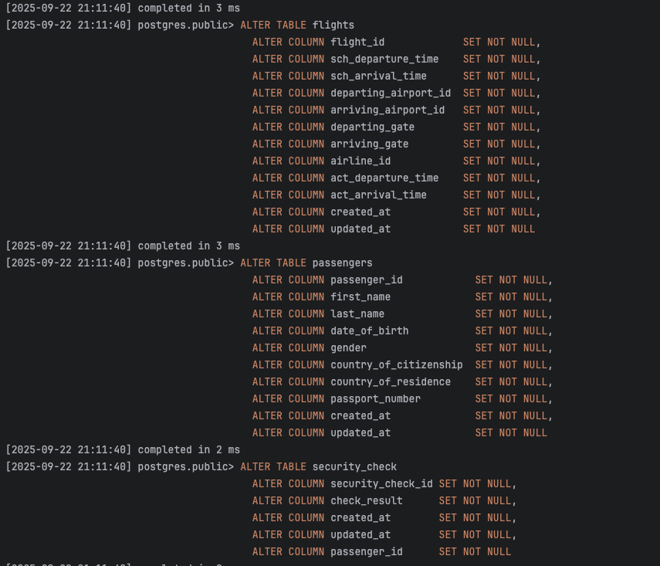

1. Renamed airline_info into airline name
2. Rename column price into ticket_price



6.changed type of departing gate



7.droped column info from airline table

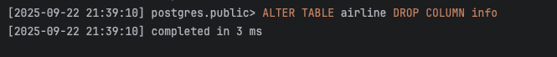

8.added relations

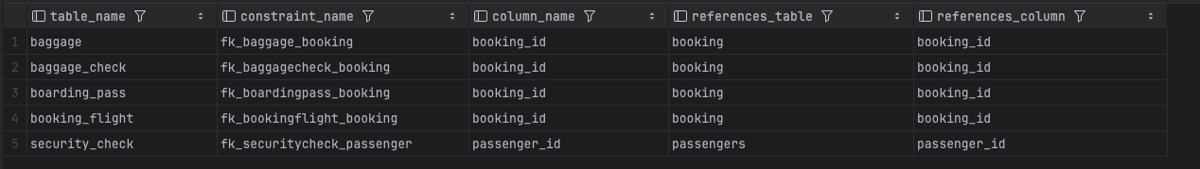

2 part of lab work

1. Generate and insert 200 random rows in your airport database.

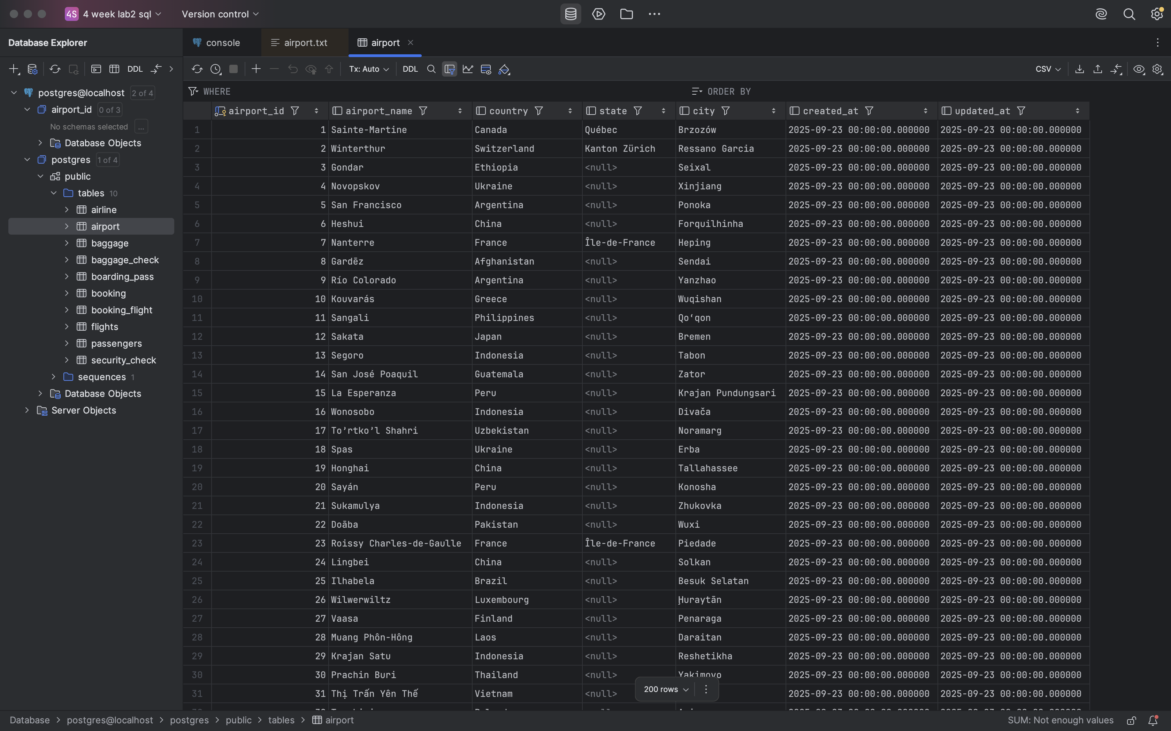

2.insert new





3.updated to Turkey



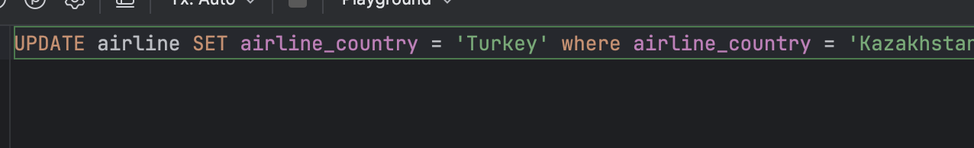

4.added new airlines

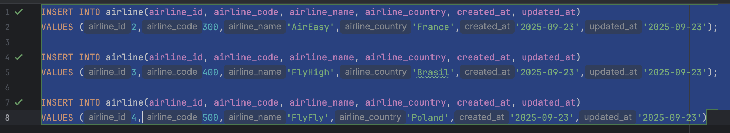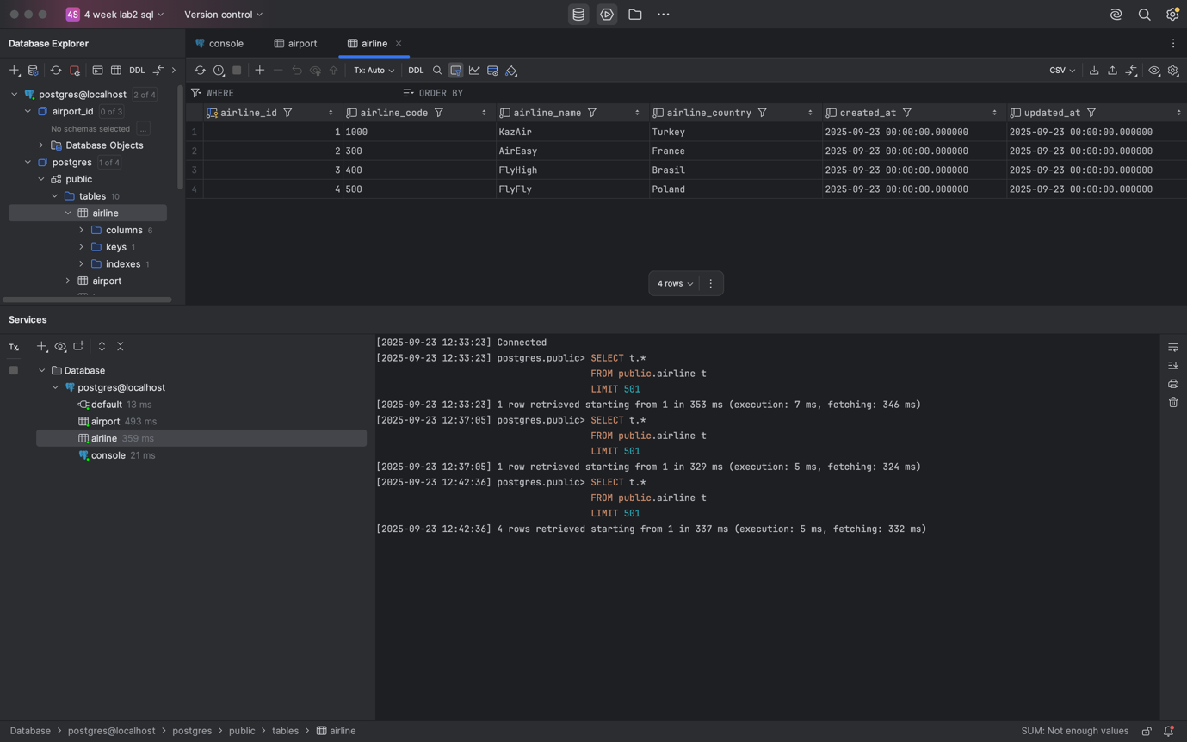

5.deleted all flights where arrival at 2024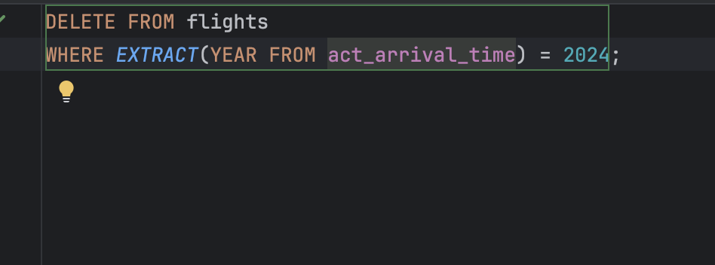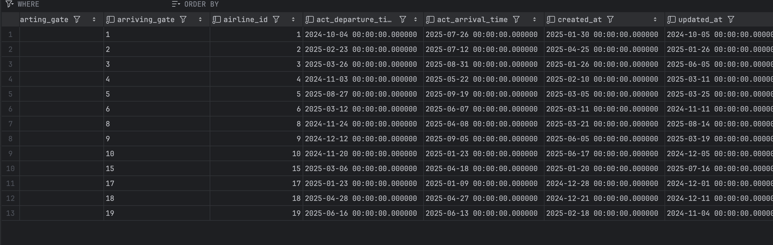

6.updated price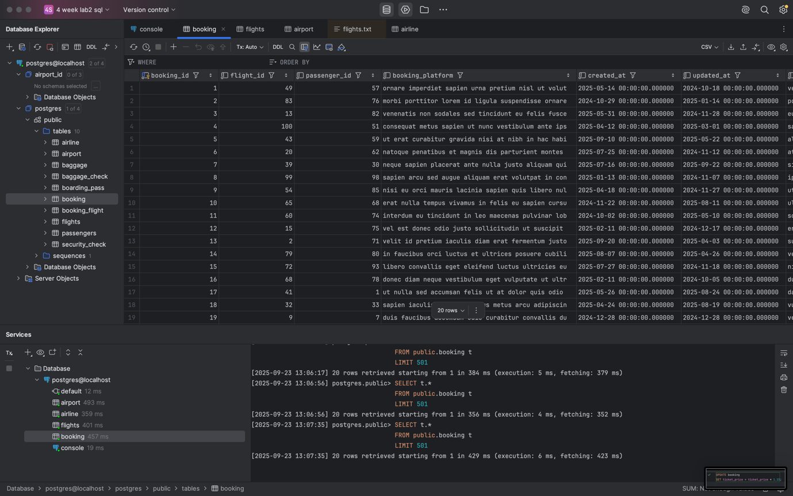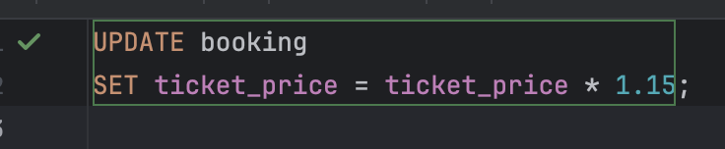

7.delete all which < 10000

